NEW-A141 Dis-Eur-Spain-Cantabria-Santander-Carmago**-**El Pendo Cave-Figurine

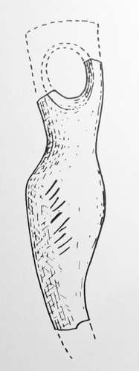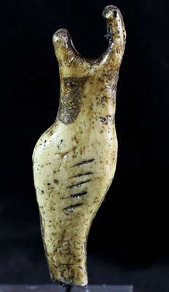

Figs. 1. Spain-Cantabria-Santander-Carmago**-**El Pendo Cave-Figure

Fig. 2. Reconstruction (Delporte 1979)

**Formal Label:** Spain-Cantabria-Santander-Carmago**-**El Pendo Cave-Figurine

**Display Description:** This Solutrean figurine is in the form of a spear straightener and is made of deer antler and was excavated by Abbé Jesus Carballo at El Pendo Cave in the Solutrean stratum 22,000 BP-17,000 BP. This **is** anabstract figurine which evokes the feminine form with arms raised and with large hips. The Soultrean industry was preceded by the Mousterian and includes tools, ornamental beads, art and bone artifacts such as this enigmatic figurine so it does fit into the Solutrean trait list.

**Accession Number:** A141

**LC Classification:** GN776.22

**Date or Time Horizon:** 22,000 BP-17,000 BP

**Geographical Area:** Cantabria

**Map, GPS coordinates:**



**After © Sémhur / Wikimedia Commons, FAL, https://commons.wikimedia.org/w/index.php?curid=8383203**

**Cultural Affiliation:** Solutrean

**Medium:** deer antler

**Dimensions:**

**Weight:**

**Condition: museum replica in resin of original**

**Provenance:** original, Santander museum ?

**Discussion:** This figurine is enigmatic, since it is broken its reconstructed form is that of a shaft straightener, many of which are known from the Upper Paleolithic. Therefore, it is improbable that this figure is actually a “Venus” figurine and more probable that it represents a hunting implement to make a spear or arrow hit its mark. It could therefore represent a ritualistic amulet for a successful hunt.

**References:**

**Delporte H.** 1979. *L'image de la femme dans l'art préhistorique*. Paris: Picard.

